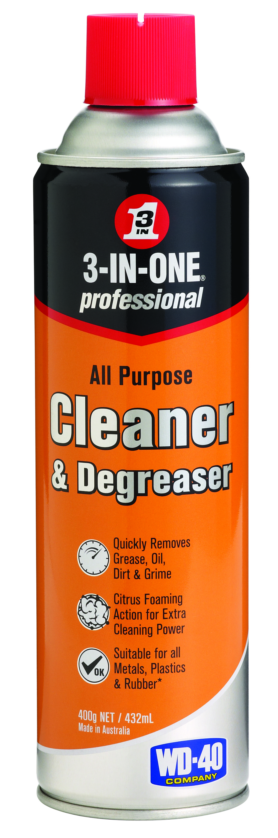
Safety Data Sheet

1 – Product Identifier & Identity for the Chemical
Manufacturer: WD-40 Company Australia Pty Ltd  Address: 41 Rawson Street  (Level 2, Suite 23)  Epping  NSW, 2121, Australia  Telephone:  Information: +61 2 9868 2200  Emergency only: 1800 862 115  Poisons Information Centre:  Australia: 13 11 26  New Zealand: 0800 764 766  New Zealand Contact Details:  Name: Eproducts New Zealand Limited  Address: 1B / 89 Ellice Road,  Wairau Valley,  Auckland 0629  New Zealand  Telephone:  Information: 09 916 6750  Emergency only: 0800 425 459 | Product Name: 3-In-One All Purpose Cleaner and Degreaser  Chemical Name: Mixture  Product Use: Cleaner and degreaser  Restriction on Use: None Identified  SDS Date of Preparation: 21 May 2026  This SDS applies to unit codes: 11064

2 – Hazards Identification

Classification of the Hazardous Chemical (in accordance with WHS Regulation)

Health | Environmental | Physical
Eye Irritant Category 2  Skin Irritant Category 2 | Aquatic Chronic Toxicity Category 3 | Aerosol Category 1

Label Elements
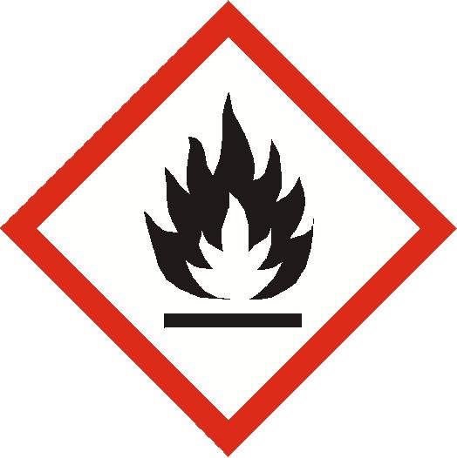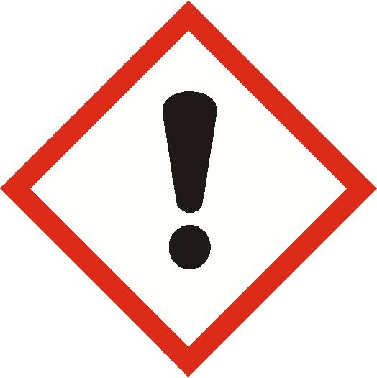
Contains: 2-Butoxyethanol, Surfactant, Monoethanolamine

Danger!
H222 Extremely flammable aerosol.
H229 Pressurized container: may burst if heated.
H315 Causes skin irritation.
H319 Causes serious eye irritation.
H412 Harmful to aquatic life with long lasting effects.

Prevention
P210 Keep away from heat, hot surfaces, sparks, open flames, and other ignition sources. No smoking.
P211 Do not spray on an open flame or other ignition source.
P251 Do not pierce or burn, even after use.
P264 Wash thoroughly after handling.
P273 Avoid release to the environment.
P280 Wear protective gloves and eye protection.
Response
P305+P351+P338 IF IN EYES: Rinse cautiously with water for several minutes. Remove contact lenses, if present and easy to do. Continue rinsing.
P337+P313 If eye irritation persists: Get medical attention.
P302+P352 IF ON SKIN: Wash with plenty of soap and water.
P332+P313 If skin irritation occurs: Get medical attention.
P362+P364 Take off contaminated clothing and wash it before reuse.
Storage
P410+P412 Protect from sunlight. Do not expose to temperatures exceeding 50°C/122°F.
Disposal
P501 Dispose of contents and container in accordance with local and national regulations.

Other Hazards that do not Result in Classification: None known.

3 - Composition/Information on Ingredients
Ingredient | CAS # | Weight Percent | Substance Classification
2- Butoxyethanol | 111-76-2 | <10% | Acute Tox. Cat 4 (H302, H312, H332)  Skin Irrit. Cat 2 (H315)  Eye Irrit. Cat 2 (H319)
Propellant (propane, n-butane, Isobutane) | 74-98-6  106-97-8  75-28-5 | <10% | Flam. Gas Cat 1 (H220)  Press. Gas (H280)
Surfactant | Proprietary | <3% | Acute Tox. Cat 4 (H302)  Eye Dam. Cat 1 (H318)  Aquatic Acute Cat 2 (H401)  Aquatic Chronic Cat 2 (H411)
D-limonene | 5989-27-5 | <1% | Flam. Liq. Cat 3 (H226)  Skin Irrit. Cat 2 (H315)  Skin Sens. Cat 1B (H317)  Asp. Tox. Cat 1 (H304)  Aquatic Acute Cat 1 (H400)  Aquatic Chronic Cat 1 (H410)
Ethanolamine | 141-43-5 | <0.5% | Acute Tox. Cat 4 (H302, H312, H332)  Skin Corr. Cat 1B (H314)  STOT SE Cat 3 (H335) Aq. Chronic Cat 3 (H412)
See Section 16 for full text of GHS Classification and H phrases

4 – First Aid Measures
Ingestion (Swallowed): Rinse out mouth and give sips of water. Do not induce vomiting unless directed to do so by medical personnel. Call a Poisons Information Center (phone 13 11 26 from anywhere in Australia or 0800 764 766 in New Zealand).
Eye Contact: Flush thoroughly with water. Remove contact lenses if present after the first 5 minutes and continue flushing for several more minutes. Get medical attention if irritation persists.
Skin Contact: Wash with soap and water. If irritation develops or rash develops and persists, get medical attention.
Inhalation (Breathing): If irritation is experienced, move to fresh air. Get medical attention if irritation or other symptoms develop and persist.
Most Important Symptoms: May cause moderate eye and skin irritation. If inhaled, may cause respiratory irritation with headache, dizziness, nausea, and other symptoms of central nervous system depression. Ingestion of the liquid may cause gastrointestinal effects with irritation, nausea, vomiting, and diarrhea.
Indication of Immediate Medical Attention and Special Treatment, if Needed: Immediate medical attention is not normally required.

5 – Fire Fighting Measures
Suitable Extinguishing Media: Use water fog, dry chemical, carbon dioxide or foam. Cool fire exposed containers with water.
Specific Hazards Arising from the Chemical: Extremely flammable aerosol. Contents under pressure. Keep away from ignition source and open fire. Exposure of containers to extreme heat and flames can cause them to rupture often with violent force. A vapor and air mixture can create an explosion hazard in confined spaces.
Special Protective Equipment and Precautions for Fire-Fighters: Firefighters should always wear positive pressure self-contained breathing apparatus and full protective clothing. Use shielding to protect against bursting containers. Cool fire-exposed containers with water.

6 – Accidental Release Measures
Personal Precautions, Protective Equipment and Emergency Procedures: Eliminate all sources of ignition and ventilate area. Wear appropriate protective clothing (see Section 8).
Environmental Precautions: Avoid releases to the environment. Report spills to authorities as required.
Methods and Materials for Containment/Cleanup: Leaking cans should be placed in a plastic bag or open pail until the pressure has dissipated. Contain and collect liquid with an inert absorbent and place in a container for disposal. Clean spill area thoroughly.

7 – Handling and Storage
Precautions for Safe Handling: Avoid contact with eyes and skin. Avoid breathing vapors or aerosols. Intentional misuse by deliberately concentrating vapors and inhaling can be harmful or fatal. Use only with adequate ventilation. Keep away from heat, sparks, pilot lights, hot surfaces, and open flames. Unplug electrical tools, motors, and appliances before spraying or bringing the can near any source of electricity. Electricity can burn a hole in the can and cause contents to burst into flames. To avoid serious burn injury, do not let the can touch battery terminals, electrical connections on motors or appliances or any other source of electricity. Wash thoroughly with soap and water after handling. Keep containers closed when not in use. Keep out of the reach of children. Do not puncture, crush, or incinerate containers, even when empty.
Conditions for Safe Storage, including any incompatibilities: Store in a cool, dry, ventilated area away from incompatible materials. Protect from physical damage. Do not store in direct sunlight, near open flames or above temperatures greater than 50°C.

8 – Exposure Controls /Personal Protection
Chemical | Occupational Exposure Limits | Biological Limit Value
2- Butoxyethanol | 20 ppm TWA, 50 ppm STEL AU OEL  25 ppm TWA NZ OEL  20 ppm TWA ACGIH TLV | Butoxyacetic acid (BAA) in urine, End of shift, 200 mg/g creatinine
D-limonene | 5 ppm TWA, 20 ppm STEL DFG MAK | None Established
Propane | Asphyxiant – See Chapter 10 of Safe Work Australia Exposure Standard  NZ-WESes: Simple Asphyxiant-may present an explosion hazard | None Established
n-Butane | 800 ppm TWA AU OEL  800 ppm TWA NZ OEL  1000 ppm STEL ACGIH TLV (as Butane, all isomers) | None Established
Iso-Butane | NZ-Simple Asphyxiant-may present an explosion hazard  1000 ppm STEL ACGIH TLV (as Butane, all isomers) | None Established
Surfactant | None Established | None Established
Ethanolamine | 3 ppm TWA, 6 ppm STEL AU OEL  3 ppm TWA, 6 ppm STEL NZ OEL  3 ppm TWA, 6 ppm STEL ACGIH TLV | None Established

The Following Controls are Recommended for Normal Consumer Use of this Product

Appropriate Engineering Controls: Use in a well-ventilated area.
Personal Protection:
Eye Protection: Avoid eye contact. Always spray product away from your face.
Skin Protection: Avoid prolonged or repeated skin contact. Chemical resistant gloves recommended for operations where skin contact is likely.
Respiratory Protection: None needed for normal use with adequate ventilation.

For Bulk Processing or Workplace Use the Following Controls are Recommended

Appropriate Engineering Controls: Use adequate general and local exhaust ventilation to maintain exposure levels below that occupational exposure limits.
Personal Protection:
Eye Protection: Safety goggles recommended where eye contact is possible.
Skin Protection: Wear chemical resistant gloves.
Respiratory Protection: None required if ventilation is adequate. If the occupational exposure limits are exceeded, wear an approved respirator. Respirator selection and use should be based on contaminant type, form, and concentration. Follow applicable regulations and good Industrial Hygiene practice.
Work/Hygiene Practices: Eye wash facilities should be available. Wash hands after handling.
Other Protective Equipment: None required.

9 – Physical and Chemical Properties
Physical State: | Liquid (aerosol spray)
Color: | Light amber | Partition Coefficient of n-octanol/water: | Not determined
Odor: | Citrus | Auto-ignition temperature: | Not determined
pH: | Not determined | Decomposition Temperature: | Not determined
Melting/Freezing Point: | Not applicable | Kinematic Viscosity: | Not determined
Boiling Point / Range: | 100°C (212°F) (Water) | Specific Heat Value: | Not determined
Flash Point: | Not determined | Particle Characteristics: | Not applicable
Evaporation Rate  (Butyl Acetate = 1): | Not determined | VOC: | Not determined
Flammability: | Not applicable | Percent Volatile: | Not determined
Flammable Limits: | LEL 0.7% (D-limonene) UEL 10.6% (2- Butoxyethanol) | Saturated Vapor Concentration: | Not determined
Vapor Pressure: | Not determined | Release of invisible flammable vapors and gases: | Not determined
Relative Vapor Density (air = 1): | Not determined | Aerosol Protection Level (NFPA 30B): | 1
Density/Relative Density (Water = 1): | Not determined | Solubility: | Miscible in water

10 – Stability and Reactivity
Reactivity: Non-reactive
Chemical Stability: Stable under normal storage conditions.
Possibility of Hazardous Reactions: Polymerization will not occur.
Conditions to Avoid: Avoid extreme heat, flames, and other sources of ignition. Avoid physical damage to aerosol can.
Incompatible Materials: Strong oxidizers.
Hazardous Decomposition Products: Carbon monoxide and carbon dioxide.

11 – Toxicological Information
Health Hazards:
Ingestion: Swallowing is an unlikely route of exposure for an aerosol product. Swallowing large amounts may produce gastrointestinal irritation, nausea, vomiting and diarrhea.
Eye Contact: Liquid sprayed into eyes may cause moderate irritation. May cause redness, stinging, swelling, and tearing.
Skin Contact: May cause moderate skin irritation with redness, itching and burning of the skin. Prolonged and/or repeated contact may cause defatting with possible dermatitis.
Inhalation: Mist or vapor can irritate the throat and lungs. High concentrations may cause nasal and respiratory irritation and central nervous system effects such as headache, dizziness, and nausea. Intentional abuse may be harmful or fatal.

Chronic Exposure: None known.
Medical Conditions Aggravated by Exposure: Preexisting eye, skin and respiratory conditions may be aggravated by exposure.

Acute Toxicity Values:
2- Butoxyethanol: Oral rat LD50: 470 mg/kg; Skin rabbit LD50: 400 mg/kg; Inhalation rat LC50: 450 ppm/4hr
Surfactant: Oral rat LD50: 1900-5000 mg/kg, Skin rabbit LD50: >3000 mg/kg
D-limonene: Oral rat LD50: 4400 mg/kg; Skin rabbit LD50: >5000 mg/kg
Ethanolamine: Oral rat LD50: 1089-1515 mg/kg, Inhalation rat LC50: 1487 mg/m3/4hr, Dermal rat LD50: 2504 mg/kg
ATE_{mix} Oral: >2,000 mg/kg; Dermal: >2,000 mg/kg; Not acutely toxic by inhalation

Skin Corrosion/Irritation: No data available for mixture. Based on the ingredients, this product is classified as a skin irritant.
Serious Eye Damage/Irritation: No data available for mixture. Based on the ingredients, this product is classified as an eye irritant.
Respiratory or Skin Sensitization: This product is not expected to cause skin sensitization.
Germ Cell Mutagenicity: None of the components have been found to be mutagenic.
Carcinogenicity: None of the components are listed as a carcinogen or suspected carcinogen by IARC, NTP, ACGIH, US OSHA or the EU CLP.
Reproductive Toxicity: None of the components are known to cause adverse reproductive effects.
Specific Target Organ Toxicity:
Single Exposure: No data available.
Repeated Exposure: No data available.
Aspiration Hazard: No data available. Based on the ingredients, this product is not expected to present an aspiration hazard.

12 – Ecological Information
Ecotoxicity:
2- Butoxyethanol: 96 hr LC50 Rainbow trout- 1464 mg/L, 48 hr EC50 Daphnia magna- 1800 mg/L
Surfactant: 96 hr LC50 Fathead minnow- 4-8.9 mg/L, 48 hr EC50 Daphnia magna- 18-26 mg/L, 16 hr IC50 Bacteria (static test)- 5000 mg/L
D-limonene: 48 hr LC50 Daphnia magna- 0.577 mg/L
Ethanolamine: 48 hr EC50 Daphnia magna: 65 mg/L

This product has been classified as harmful to the aquatic environment with long lasting effects based on the components. Releases to the environment should be avoided.

Persistence and Degradability: No data available.
Bioaccumulative Potential: No data available.
Mobility in Soil: No data available.
Other Adverse Effects: None Known

13 - Disposal Considerations
Safe Handling and Disposal Method: Aerosol containers should not be punctured, compacted in home trash compactors, or incinerated.
Disposal of Contaminated Packaging: Empty containers may be disposed of through normal waste management options.
Environmental Regulations: Dispose of all waste product, absorbents, and other materials in accordance with applicable Federal, state, and local regulations.

14 – Transportation Information
IMDG Shipping Name: Aerosols
IMDG Hazard Class: 2.1
UN Number: UN1950
Marine Pollutant: No

IATA Shipping Name: Aerosols, Flammable
IATA Hazard Class: 2.1
UN Number: UN1950

ADG Shipping Name: Aerosols
ADG Hazard Class: 2.1
UN Number: UN1950
Hazchem (Emergency Action) Code: N/A

Special Precautions for User: WD-40 Company does not test aerosol cans to assure that they meet the pressure and other requirements for transport by air. We do not recommend that our aerosol products be transported by air.

15 – Regulatory Information
Montreal Protocol (Ozone Depleting Substances): None present
The Stockholm Convention (Persistent Organic Pollutants): None present
The Rotterdam Convention (Prior Informed Consent): Not applicable
Basel Convention: Not applicable
International Convention for the Prevention of Pollution from Ships (MARPOL): D-Limonene (as Dipentene) is listed.
Standard for the Uniform Scheduling of Medicines and Poisons (SUSMP): Not applicable

Australian Inventory of Chemical Substances: All of the components of this product are listed on the AICS inventory.

New Zealand:
HSNO Approval Number: HSR002515
Considered a Hazardous Substance according to the criteria of the New Zealand Hazardous Substances New Organisms legislation. Classified as Dangerous Good for transport purposes.

HSNO Hazard Classes: 2.1.2A, 6.3A, 6.4A, 9.1C

New Zealand Inventory: All the ingredients comply with the HSNO regulations.

16 – Other Information
REVISION DATE: 21 May 2026 SUPERSEDES: 5 February 2026

Revision History:
May 21, 2026: Updated address

Prepared By: IHSC, LLC

Full Text of GHS Classification and H Phrases from Section 3:
Acute Tox. Cat 4 Acute Toxicity Category 4
Aq. Acute Cat 1 Aquatic Acute Toxicity Category 1
Aq. Acute Cat 2 Aquatic Acute Toxicity Category 2
Aq. Chronic Cat 1 Aquatic Chronic Toxicity Category 1
Aq. Chronic Cat 2 Aquatic Chronic Toxicity Category 2
Aq. Chronic Cat 3 Aquatic Chronic Toxicity Category 3
Asp. Tox. Cat 1 Aspiration Toxicity Category 1
Eye Dam. Cat 1 Eye Damage Category 1
Eye Irrit. Cat 2 Eye Irritant Category 2
Flam. Gas Cat 1 Flammable Gas Category 1
Flam. Liq. Cat 3 Flammable Liquid Category 3
Skin Corr. Cat 1B Skin Corrosion Category 1B
Skin Irrit. Cat 2 Skin Irritant Category 2
Skin Sens. Cat 1B Skin Sensitization Category 1B
STOT SE Cat 3 Specific Target Organ Toxicity Single Exposure Category 3
Press. Gas Compressed Gas
H220 Extremely flammable gas.
H226 Flammable liquid and vapor.
H280 Contains gas under pressure; may explode if heated.
H302 Harmful if swallowed.
H304 May be fatal if swallowed and enters airways.
H312 Harmful in contact with skin.
H314 Causes severe skin burns and eye damage.
H315 Causes skin irritation.
H317 May cause an allergic skin reaction.
H318 Causes serious eye damage.
H319 Causes serious eye irritation.
H332 Harmful if inhaled.
H335 May cause respiratory irritation.
H400 Very toxic to aquatic life.
H401 Toxic to aquatic life.
H410 Very toxic to aquatic life with long lasting effects.
H411 Toxic to aquatic life with long lasting effects.
H412 Harmful to aquatic life with long lasting effects.

List of Abbreviations or Acronyms:
ACGIH American Conference of Industrial Hygienists
ADG Australian Dangerous Goods
AICS Australian Inventory of Chemical Substances
AU Australia
EC Effective Concentration
EU European Union
GHS Globally Harmonized System of Classification and Labelling of Chemicals
HSNO Hazardous Substances and New Organisms
IARC International Agency of Research on Cancer
IATA International Air Transport Association
IMDG International Maritime Dangerous Goods
LC Lethal Concentration
LD Lethal Dosage
LEL Lower Explosive Limit
NTP National Toxicology Program
NZ New Zealand
OEL Occupational Exposure Limits
PEL Permissible Exposure Limit
SDS Safety Data Sheet
STEL Short Term Exposure Limit
TWA Time-Weighted Average
UEL Upper Explosive Limit
US OSHA United States Occupational Safety and Health Administration
VOC Volatile Organic Compounds
WHS Work Health and Safety

SIGNATURE: Inez Kowalski TITLE Regulatory Affairs Department

This SDS complies with Australian guidelines for SDS. The foregoing information has been compiled from sources believed to be accurate but is not warranted to be. Recipients are advised to confirm in advance of need that data is correct. Standards change without notice. It is the responsibility of the recipient to insure that their personnel have been notified of any changes which may affect them. The data provided on this SDS are not meant to be used as specifications, only as guideline information as to the safe use of this product. User should refer to applicable laws before use.

3017100/No.

