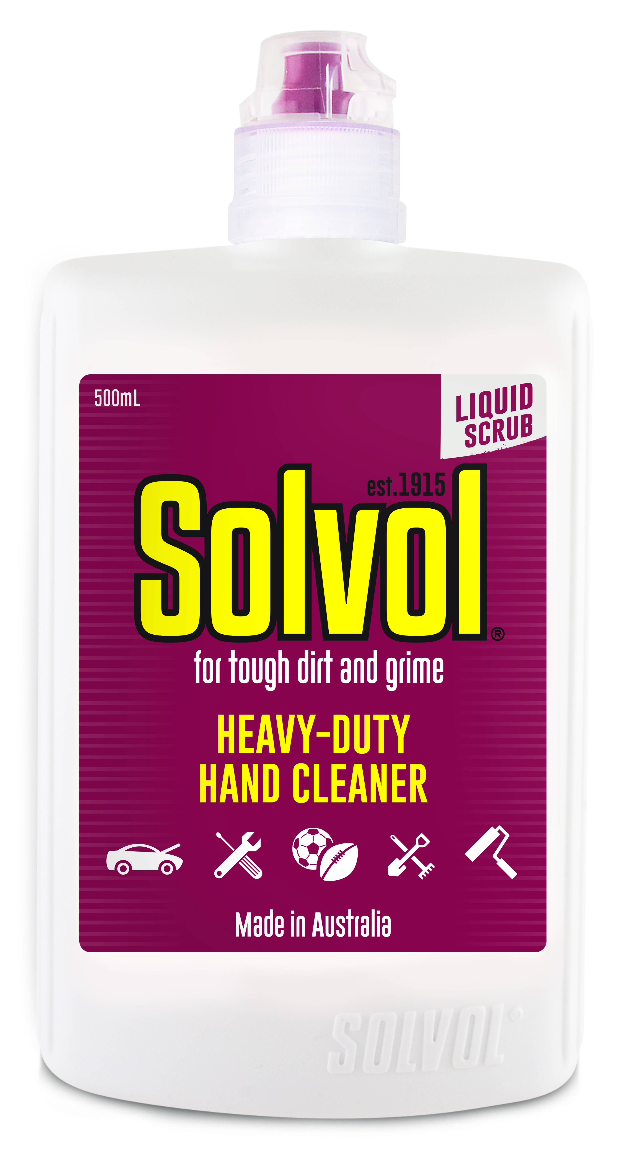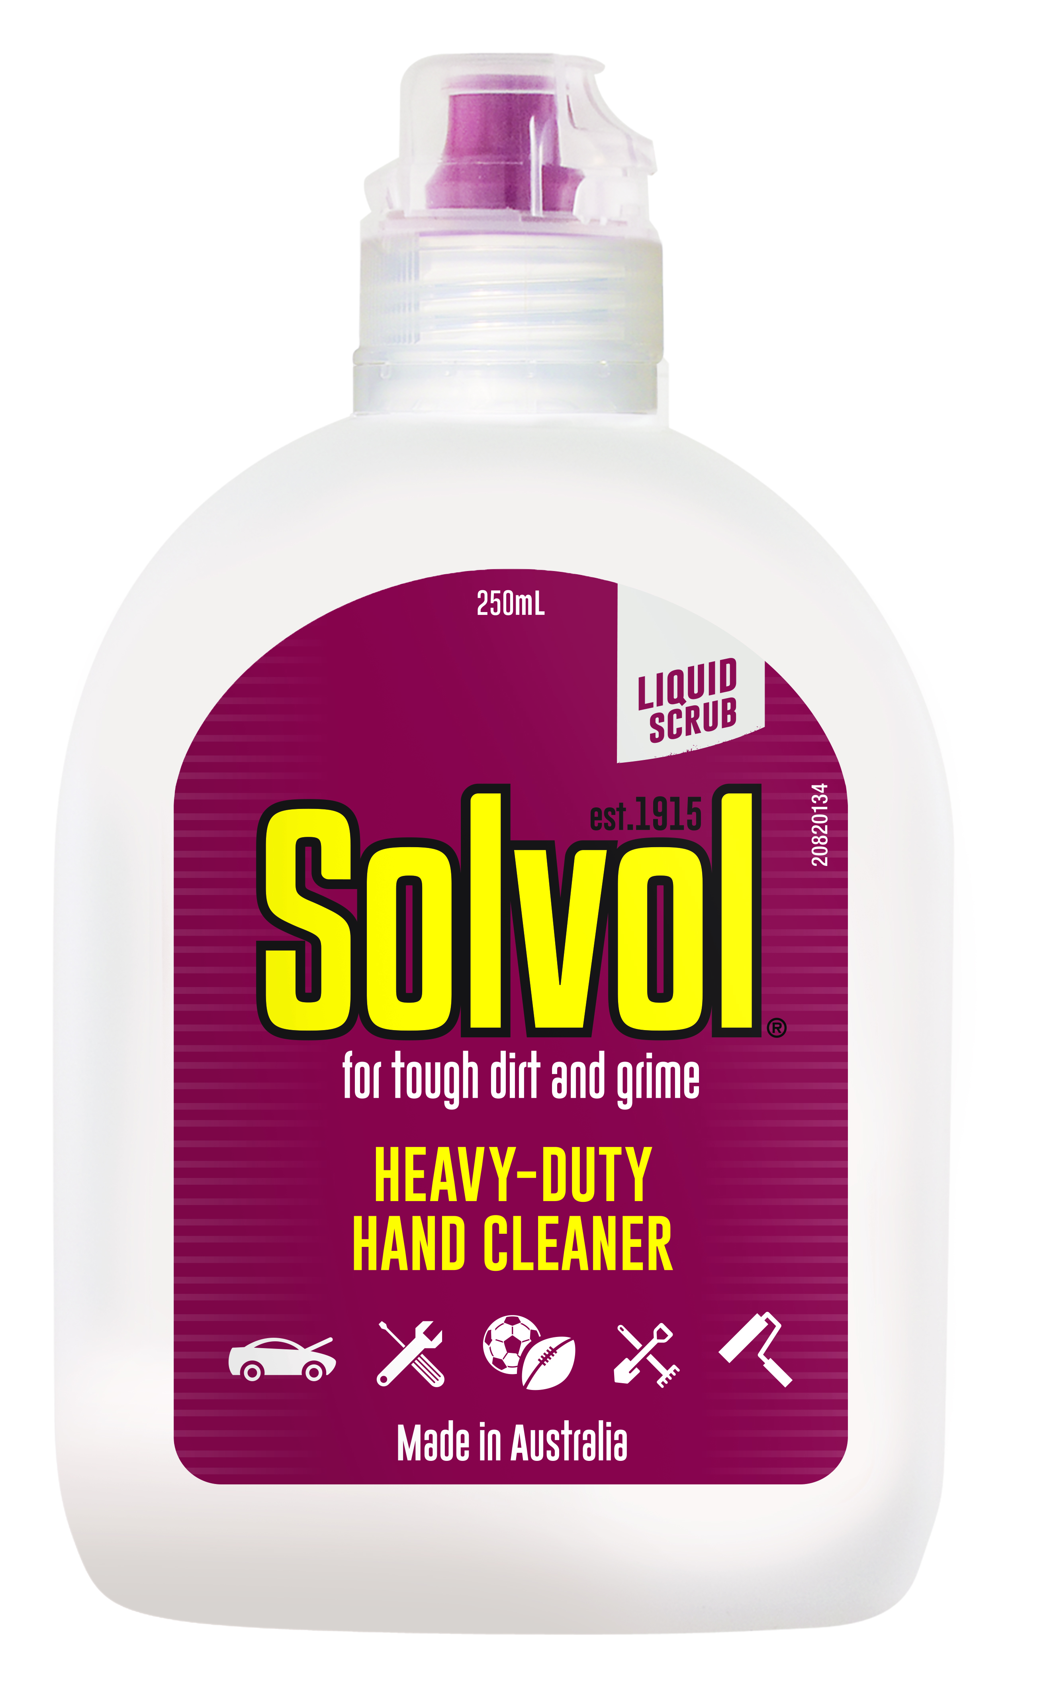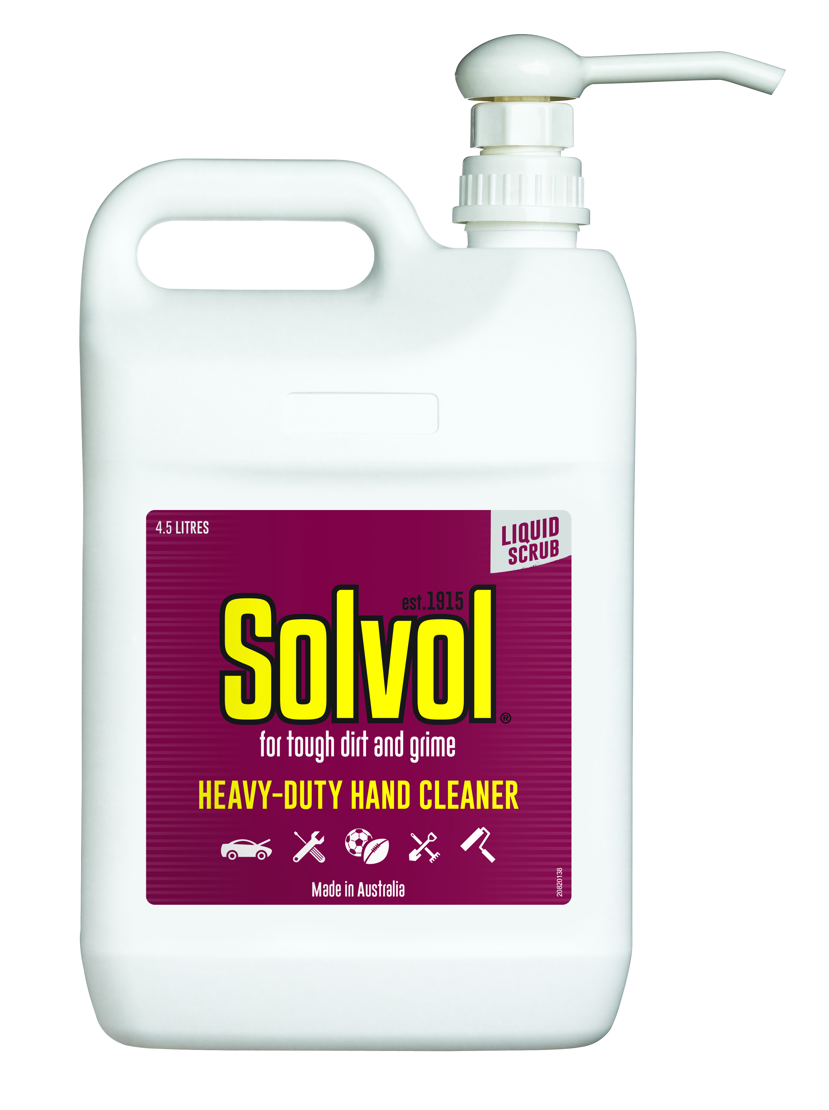
Safety Data Sheet

1 – Product Identifier & Identity for the Chemical
Manufacturer: WD-40 Company Australia Pty Ltd  Address: 41 Rawson Street  (Level 2, Suite 23)  Epping  NSW, 2121, Australia  Telephone:  Information: +61 2 9868 2200  Emergency only: 1800 862 115  Poisons Information Centre:  Australia: 13 11 26  New Zealand: 0800 764 766  New Zealand Contact Details:  Name: Eproducts New Zealand Limited  Address: 1B / 89 Ellice Road,  Wairau Valley,  Auckland 0629  New Zealand  Telephone  Information: 09 916 6750  Emergency only: 0800 425 459 | Product Name: Solvol Liquid  Chemical Name: Mixture  Product Use: Liquid hand soap  Restriction on Use: None Identified  SDS Date of Preparation: 21 May 2026  This SDS applies to unit codes: 71025, 71050, 71041, 71026

2 – Hazards Identification

Classification of the Hazardous Chemical (in accordance with WHS Regulation)

Health | Environmental | Physical
Eye Irritant Category 2A  Skin Sensitizer Category 1 | Aquatic Acute Toxicity Category 3  Aquatic Chronic Toxicity Category 3 | Not Hazardous

Label Elements
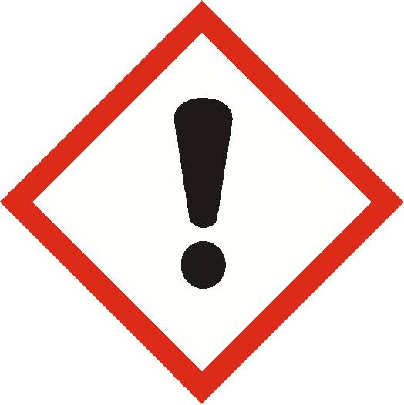
Contains: Cocamidopropyl betaine

Danger!
H317 May cause an allergic skin reaction.
H319 Causes serious eye irritation.
H412 Harmful to aquatic life with long lasting effects.

Prevention
P261 Avoid breathing mist, vapors, or spray.
P264 Wash hands thoroughly after handling.
P272 Contaminated work clothing should not be allowed out of the workplace.
P273 Avoid release to the environment.
P280 Wear eye protection and protective gloves.
Response
P302+P352 IF ON SKIN: Wash with plenty of water.
P333+P313 If skin irritation or rash occurs: Get medical attention.
P362+P364 Take off contaminated clothing and wash it before reuse.
P305+P351+P338 IF IN EYES: Rinse cautiously with water for several minutes. Remove contact lenses, if present and easy to do. Continue rinsing.
P337+P313 If eye irritation persists: Get medical attention.
Disposal
P501 Dispose of contents and container in accordance with local and national regulations.

Other Hazards that do not Result in Classification: None

3 - Composition/Information on Ingredients
Ingredient | CAS # | Weight Percent | Substance Classification
Non-Hazardous Ingredients | Mixture | >60% | Not Hazardous
Perlite | 93763-70-3 | <10% | Eye Irrit. Cat 2A (H319)  STOT SE Cat 3 (H335)
Glycerin | 56-81-5 | <10% | Not Hazardous
Alcohols, C12-14, ethoxylated, sulfates, sodium salts | 68891-38-3 | <2% | Eye Dam. Cat 1 (H318)  Skin Irrit. Cat 2 (H315)  Aq. Acute Cat 2 (H401) Aq. Chronic Cat 3 (H412)
Cocamidopropyl betaine | 61789-40-0 | <2% | Eye Dam. Cat 1 (H318)  Skin Irrit. Cat 2 (H315)  Skin Sens. Cat 1 (H317)  Aq. Acute Cat 2 (H401) Aq. Chronic Cat 3 (H412)
D-limonene | 5989-27-5 | <0.5% | Flam. Liq. Cat 3 (H226)  Skin Irrit. Cat 2 (H315)  Skin Sens. Cat 1B (H317)  Asp. Tox. Cat 1 (H304)  Aq. Acute Cat 1 (H400)  Aq. Chronic Cat 1 (H410)
See Section 16 for full text of GHS Classification and H phrases

4 – First Aid Measures
Ingestion (Swallowed): Rinse out mouth and give sips of water. Do not induce vomiting unless directed to do so by medical personnel. Call a Poisons Information Center (phone 13 11 26 from anywhere in Australia or 0800 764 766 in New Zealand).
Eye Contact: Flush thoroughly with water. Remove contact lenses if present after the first 5 minutes and continue flushing for several more minutes. Get medical attention if irritation persists.
Skin Contact: Wash with water for several minutes. Get medical attention if irritation or rash occurs.
Inhalation (Breathing): If irritation is experienced, move to fresh air. Get medical attention if irritation or other symptoms develop and persist.
Most Important Symptoms: May cause moderate eye irritation. Prolonged skin contact may cause drying of the skin. Skin contact may cause an allergic skin reaction. Accidental ingestion may cause gastrointestinal effects with irritation, nausea, vomiting, and dizziness.
Indication of Immediate Medical Attention and Special Treatment, if Needed: Immediate medical attention is not normally required.

5 – Fire Fighting Measures
Suitable Extinguishing Media: This product is not flammable or combustible. Use any media that is appropriate for the surrounding fire.
Specific Hazards Arising from the Chemical: This product is not classified as flammable or combustible but will burn under fire conditions after the water has evaporated. Thermal decomposition may release carbon oxides.
Special Protective Equipment and Precautions for Fire-Fighters: Firefighters should always wear positive pressure self-contained breathing apparatus and full protective clothing in areas where chemicals are used and stored. Cool fire-exposed containers with water.

6 – Accidental Release Measures
Personal Precautions, Protective Equipment and Emergency Procedures: Wear appropriate protective clothing (see Section 8). Avoid contact with the spilled material.
Environmental Precautions: Avoid releases to the environment. Report spills to authorities as required.
Methods and Materials for Containment/Cleanup: Contain and collect liquid with an inert absorbent material and place in a container for disposal. Clean spill area thoroughly.

7 – Handling and Storage
Precautions for Safe Handling: Avoid contact with eyes, skin, and clothing. Avoid breathing vapors or mists. Use with adequate ventilation. Keep container closed when not in use. Immediately remove any contaminated clothing and launder before reuse. Wash thoroughly after use. Keep out of the reach of children. Do not use with any other cleaning agents or household chemicals. Dangerous reactions may occur.
Conditions for Safe Storage, including any incompatibilities: Store in a cool, dry ventilated area away from incompatible materials. Protect from physical damage.

8 – Exposure Controls /Personal Protection
Chemical | Occupational Exposure Limits | Biological Limit Value
Non-Hazardous Ingredients | None Established | None Established
Perlite | 10 mg/m3 TWA AU OEL (as dust)  10 mg/m3 TWA NZ WES | None Established
Glycerin (as mist) | 10 mg/m3 TWA AU OEL  10 mg/m3 TWA NZ OEL/WES | None Established
Alcohols, C12-14, ethoxylated, sulfates, sodium salts | None Established | None Established
Cocamidopropyl betaine | None Established | None Established
D-limonene | 5 ppm TWA, 20 ppm STEL DFG MAK | None Established

The Following Controls are Recommended for Normal Consumer Use of this Product
Appropriate Engineering Controls: Use in a well-ventilated area.
Personal Protection:
Eye Protection: Avoid eye contact. Safety glasses or goggles recommended.
Skin Protection: Avoid prolonged or repeated skin contact. Chemical resistant gloves are recommended for operations where skin contact is likely.
Respiratory Protection: None needed for normal use with adequate ventilation.

For Bulk Processing or Workplace Use the Following Controls are Recommended
Appropriate Engineering Controls: Use adequate general and local exhaust ventilation to maintain exposure levels below the occupational exposure limits.
Personal Protection:
Eye Protection: Safety goggles recommended where eye contact is possible.
Skin Protection: Wear chemical resistant gloves.
Respiratory Protection: None required if ventilation is adequate. If the occupational exposure limits are exceeded, wear an approved respirator. Respirator selection and use should be based on contaminant type, form and concentration. Follow applicable regulations and good Industrial Hygiene practice.
Work/Hygiene Practices: Eye wash facilities should be available. Wash hands after handling.
Other Protective Equipment: None required.

9 – Physical and Chemical Properties
Appearance and Odor: | Beige liquid with a citrus odor | Partition Coefficient of n-octanol/water: | Not determined
Odor Threshold: | Not determined | Auto-ignition temperature: | Not determined
pH: | Not determined | Decomposition Temperature: | Not determined
Melting/Freezing Point: | Not determined | Viscosity: | Not determined
Boiling Point / Range: | Not determined | Specific Heat Value: | Not determined
Flash Point: | Not determined | Particle Size: | Not applicable
Evaporation Rate  (Butyl Acetate = 1): | Not determined | VOC: | Not determined
Flammability (solid, gas): | Not applicable | Percent Volatile: | Not determined
Flammable Limits: | Not determined | Saturated Vapor Concentration: | Not determined
Vapor Pressure: | Not determined | Release of invisible flammable vapors and gases: | Not determined
Vapor Density (air = 1): | Not determined | Aerosol Protection Level (NFPA 30B): | Not applicable
Relative Density (Water = 1): | Not determined | Solubility: | Immiscible in water

10 – Stability and Reactivity
Reactivity: Non-reactive
Chemical Stability: Stable under normal storage conditions.
Possibility of Hazardous Reactions: Will not occur.
Conditions to Avoid: Avoid extreme heat, flames and other sources of ignition.
Incompatible Materials: Strong oxidizers.
Hazardous Decomposition Products: Carbon monoxide and carbon dioxide.

11 – Toxicological Information
Health Hazards:
Ingestion: Swallowing large amounts may produce gastrointestinal irritation, nausea, vomiting and diarrhea.
Eye Contact: Direct contact will cause moderate irritation with redness, stinging, swelling, and tearing.
Skin Contact: May produce skin irritation. Prolonged and/or repeated contact may cause defatting with possible dermatitis. Repeated contact may result in an allergic skin reaction.
Inhalation: Inhalation of mists or vapors may cause mild irritation to the eyes, mucous membranes of the throat and nose and upper respiratory tract.
Chronic Exposure: None known.
Medical Conditions Aggravated by Exposure: Preexisting eye, skin and respiratory conditions may be aggravated by exposure.

Acute Toxicity Values:
Perlite: Oral mouse LD50: 12960 mg/kg
Glycerin: Oral rat LD50: >5000 mg/kg
Alcohols, C12-14, ethoxylated, sulfates, sodium salts: Oral rat LD50: >5000 mg/kg, Skin rat LD50: >2000 mg/kg
Cocamidopropyl betaine: Oral rat LD50: >5000 mg/kg, Skin rabbit LD50: >2000 mg/kg
D-limonene: Oral rat LD50: 4400 mg/kg; Skin rabbit LD50: >5000 mg/kg
ATE_{mix} Oral: >2,000 mg/kg; Dermal: >2,000 mg/kg; Not acutely toxic by inhalation

Skin Corrosion/Irritation: No data available for mixture. Based on the ingredients, this product is not classified as a skin irritant.
Serious Eye Damage/Irritation: No data available for mixture. Based on the ingredients, this product is classified as an eye irritant.
Respiratory or Skin Sensitization: This product is expected to cause skin sensitization.
Germ Cell Mutagenicity: None of the components have been found to be mutagenic.
Carcinogenicity: None of the components are listed as a carcinogen or suspected carcinogen by IARC, NTP, ACGIH, US OSHA or the EU CLP.
Reproductive Toxicity: None of the components are known to cause adverse reproductive effects.
Specific Target Organ Toxicity:
Single Exposure: No data available.
Repeated Exposure: No data available.
Aspiration Hazard: No data available. Based on the ingredients, this product is not expected to present an aspiration hazard.

12 – Ecological Information
Ecotoxicity:
Alcohols, C12-14, ethoxylated, sulfates, sodium salts: 28 days NOEC Rainbow trout- 0.14 mg/L, 21 days NOEC Daphnia manga- 0.27 mg/L
Cocamidopropyl betaine: 96 hr LC50 Zebra fish: 2.0 mg/L, 48 hr EC50 Daphnia magna: 6.4 mg/L, 96 hr EC50 Scenedesmus subspicatus (algae): 0.55 mg/L, 28 days NOEC Rainbow trout: 0.16 mg/L, 21 day NOEC Daphnia magna: 0.9 mg/L
D-limonene: 96hr LC50 Fathead minnow: 0.72 mg/L, 48hr EC50 Daphnia magna: 0.307 mg/L, 21 days EC50 Daphnia magna: 0.188 mg/L, 21 days EC10 Daphnia magna: 0.153 mg/L

This product has been classified as harmful to the aquatic environment with long lasting effects based on the components. Releases to the environment should be avoided.

Persistence and Degradability: This product was tested for degradability following OECD 301. The results were 86% degraded in 28 days. This product is considered biodegradable. Product biodegradability testing is not applicable to aquatic toxicity classification under the GHS at this time. Therefore, the GHS classification of this product is based solely on the GHS mixture approach and includes a chronic classification.

Bioaccumulative Potential: No data available.
Mobility in Soil: No data available.
Other Adverse Effects: None Known

13 - Disposal Considerations
Safe Handling and Disposal Method: Dispose as appropriate for oil waste.
Disposal of Contaminated Packaging: Empty containers may be disposed of through normal waste management options.
Environmental Regulations: Dispose of all waste product, absorbents, and other materials in accordance with applicable Federal, state and local regulations.

14 – Transportation Information
IMDG Shipping Name: Not Regulated
IMDG Hazard Class: None
UN Number: None
Marine Pollutant: No

IATA Shipping Name: Not Regulated
IATA Hazard Class: None
UN Number: None

ADG Shipping Name: Not Regulated
ADG Hazard Class: None
UN Number: None
Hazchem (Emergency Action) Code: None

Special Precautions for User: WD-40 Company does not test containers to ensure that they meet the pressure and other requirements for transport by air. We do not recommend that our products be transported by air.

15 – Regulatory Information
Montreal Protocol (Ozone Depleting Substances): None present
The Stockholm Convention (Persistent Organic Pollutants): None present
The Rotterdam Convention (Prior Informed Consent): Not applicable
Basel Convention: Not applicable
International Convention for the Prevention of Pollution from Ships (MARPOL): D-Limonene (as Dipentene) is listed.
Standard for the Uniform Scheduling of Medicines and Poisons (SUSMP): None present

Australian Inventory of Chemical Substances: All the components of this product are listed on the AICS inventory.

New Zealand:
HSNO Approval Number: HSR002552
Considered a Hazardous Substance according to the criteria of the New Zealand Hazardous Substances New Organisms legislation. Not classified as Dangerous Good for transport purposes.

HSNO Hazard Classes: 6.4A, 6.5B, 9.1D, 9.1C

New Zealand Inventory: All the ingredients comply with the HSNO regulations.

16 – Other Information
REVISION DATE: 21 May 2026 SUPERSEDES: 10 October 2025

Revision History:
21 May 2026: Updated address
Prepared By: IHSC, LLC.

Full Text of GHS Classification and H Phrases from Section 3:
Aq. Acute Cat 1 Aquatic Acute Toxicity Category 1
Aq. Acute Cat 2 Aquatic Acute Toxicity Category 2
Aq. Chronic Cat 1 Aquatic Chronic Toxicity Category 1
Aq. Chronic Cat 3 Aquatic Chronic Toxicity Category 3
Asp. Tox. Cat 1 Aspiration Toxicity Category 1
Eye Dam. Cat 1 Eye Damage Category 1
Eye Irrit. Cat 2A Eye Irritant Category 2A
Flam. Liq. Cat 3 Flammable Liquid Category 3
Skin Irrit. Cat 2 Skin Irritant Category 2
Skin Sens. Cat 1 Skin Sensitizer Category 1
STOT SE Cat 3 Specific Target Organ Toxicity Single Exposure Category 3
H226 Flammable liquid and vapor.
H304 May be fatal if swallowed and enters airways.
H315 Causes skin irritation.
H317 May cause an allergic skin reaction.
H318 Causes serious eye damage.
H319 Causes serious eye irritation.
H335 May cause respiratory irritation.
H400 Very toxic to aquatic life.
H401 Toxic to aquatic life.
H410 Very toxic to aquatic life with long lasting effects.
H412 Harmful to aquatic life with long lasting effects.

List of Abbreviations or Acronyms:
ACGIH American Conference of Industrial Hygienists
ADG Australian Dangerous Goods
AICS Australian Inventory of Chemical Substances
AU Australia
EC Effective Concentration
EU European Union
GHS Globally Harmonized System of Classification and Labelling of Chemicals
HSNO Hazardous Substances and New Organisms
IARC International Agency of Research on Cancer
IATA International Air Transport Association
IMDG International Maritime Dangerous Goods
LC Lethal Concentration
LD Lethal Dosage
LEL Lower Explosive Limit
NTP National Toxicology Program
NZ New Zealand
OEL Occupational Exposure Limits
PEL Permissible Exposure Limit
SDS Safety Data Sheet
STEL Short Term Exposure Limit
TWA Time-Weighted Average
UEL Upper Explosive Limit
US OSHA United States Occupational Safety and Health Administration
VOC Volatile Organic Compounds
WHS Work Health and Safety

SIGNATURE: Inez Kowalski TITLE: Manager Regulatory Affairs

This SDS complies with Australian guidelines for SDS. The foregoing information has been compiled from sources believed to be accurate but is not warranted to be. Recipients are advised to confirm in advance of need that data is correct. Standards change without notice. It is the responsibility of the recipient to insure that their personnel have been notified of any changes which may affect them. The data provided on this SDS are not meant to be used as specifications, only as guideline information as to the safe use of this product. User should refer to applicable laws before use.
/No.

